**2017**

1. How is the refractive index of a material related to
   1. Real and apparent depth
   2. Velocity of light in vacuum or air and the velocity of light in a given medium [2 marks]
2. State the conditions required for total internal reflection of light to take place [2 marks]
3. Draw a ray diagram to show the refraction of a monochromatic ray through a prism when it suffers minimum deviation [2 marks]
4. A ray of light travels from water to air as shown in the diagram given below

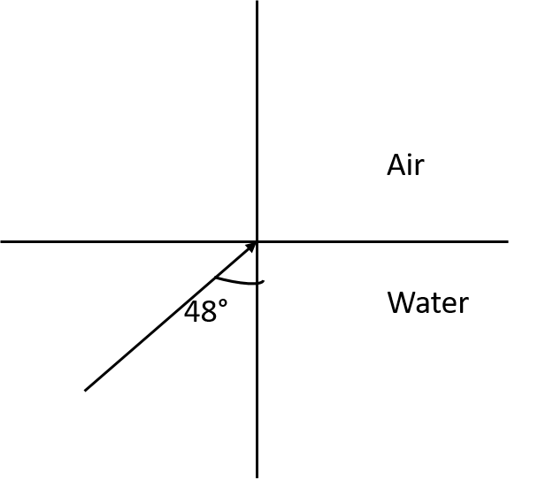

* 1. Copy the diagram and complete the path of the ray. Given, the critical angle for water is 48°
  2. State the condition, so that total internal reflection occurs in the above diagram [3 marks]

1. The diagram below shows a point source ‘P’ inside a water container. Four rays A,B,C and D starting from source ‘P’ are shown up to the water surface

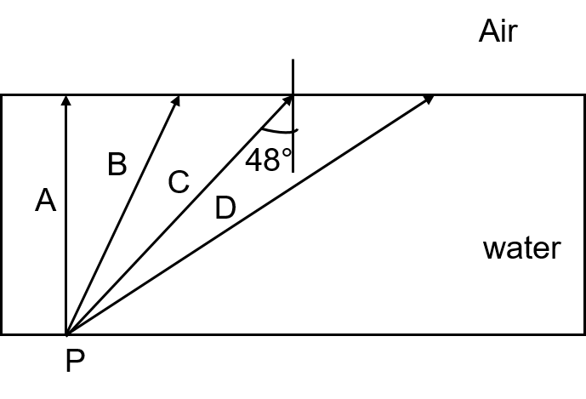

* 1. Show in the diagram, the path of these rays after striking the water surface. The critical angle for water-air surface is 48°
  2. Name the phenomenon which the rays B and D exhibit [4 marks]

**2016**

1. A boy uses blue color of light to find the refractive index of glass. He then repeats the experiment using red color light. Will the refractive index be the same or different in the two cases? Give a reason to support your answer. **[2 marks]**
2. Copy the diagram given below and complete the path of light ray till it emerges out of the prism. The critical angle of glass is 42°. In your diagram mark the angles wherever necessary. **[2 marks]**

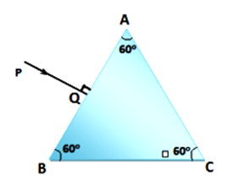

1. State the dependence of angle of deviation: **[2 marks]**
   1. On the refractive index of the material of the prism
   2. On the wavelength of light

**2015**

1. The speed of light in glass is 2x105 Km/s. what is the refractive index of the glass? **[2 marks]**
2. (I) Name the high energetic invisible electromagnetic waves which help in the study of the structure of crystals

(II) State an additional use of the waves mentioned in part (I) **[2 marks]**

1. (I) Where should an object be placed so that a real and inverted image of the same size as the object is obtained using a convex lens?

(II) Draw a diagram to show the formation of the image as specified in part (I) **[3 marks]**

1. (I) Why does the sun appear red at sunrise?

(II) Name the subjective property of light related to its wavelength **[3 marks]**

1. Jatin puts a pencil into a glass container having water and is surprised to see the pencil in a different state.
   1. What change is observed in the appearance of the pencil?
   2. Name the phenomenon responsible for the change?
   3. Draw a ray diagram showing how the eye sees the pencil. **[4 marks]**

**2014**

1. Draw the diagram given below and clearly show the path taken by the emergent ray. **[2 marks]**

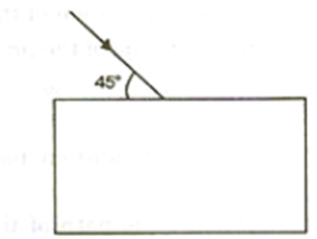

1. (I) A ray of light passes from water to air. How does the speed of light change?

(II) Which color of light travels fastest in any medium except air? **[2 marks]**

1. Name the factors affecting the critical angle for the pair of media. **[2 marks]**
2. (I) Name a prism required for obtaining a spectrum of UV light

(II) Name the radiations which can be detected by a thermopile **[2 marks]**

1. (I) Light passes through a rectangular glass slab and through a triangular glass prism. In what way does the direction of the two emergent beams differ and why?

(II) Ranbir claims to have obtained an image twice the size of the object with a concave lens. Is he correct? Give a reason for your answer **[4 marks]**

1. A lens forms an erect, magnified and virtual image of an object
   1. Name the lens
   2. Draw a labelled diagram to show the image formation **[3 marks]**
2. (I) Define the power of a lens

(II) A convex lens has a focal length of 25 cm. Calculate the power of the lens. **[3 marks]**

**2013**

1. A ray of light is moving from a rarer medium to a denser medium and strikes a plane mirror placed at 90° to the direction of the ray as shown in the diagram

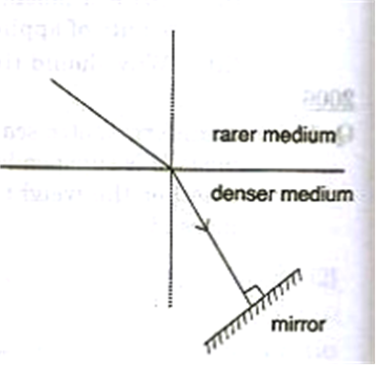

(I) Copy the diagram and mark arrows to show the path of the ray of light after it is reflected from the mirror

(II) Name the principle you have used to mark the arrow to show the direction of the ray **[2 marks]**

1. (I) The refractive index of glass with respect to air is 1.5. What is the value of the refractive index of air with respect to glass?

(II) A ray of light is incident as a normal ray on the surface of separation of two different mediums. What is the value of the angle of incidence in this case? **[2 marks]**

1. Name the radiations:
2. that are used for photography at night
3. used for detection of fracture in bones
4. whose wavelength range is from 100 Å to 4000 Å (or 10 nm to 400 nm) **[3 marks]**
5. (I) Can the absolute refractive index of a medium be less than one?

(II) A coin placed at the bottom of a beaker appears to be raised by 4 cm. If the refractive index of water is 4/3, find the depth of the water in the beaker. **[3 marks]**

1. An object AB is placed between 2F1 and F1 on the principal axis of a convex lens as shown in the diagram:

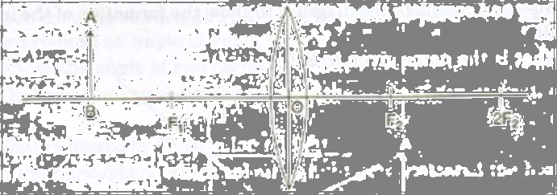

Copy the diagram and using three rays starting from point A, obtain the image of the object formed by the lens. **[4 marks]**

**2012**

1. (i) Define the refractive index of a medium in terms of velocity of light.

(ii) A ray of light moves from a rare medium to a dense medium as shown in the diagram below. Write down the number of the ray which represents the partially reflected ray. **[2 marks]**



1. You are provided with a printed piece of paper. Using this paper how will you differentiate between a convex lens and a concave lens? **[2 marks]**
2. A ray of light incident at an angle of incidence ‘i’ passes through an equilateral glass prism such that the refracted ray inside the prism is parallel to its base and emerges from the prism at an angle of emergence ‘e’.

(i) How is the angle of emergence ‘e’ related to the angle of incidence ‘i’?

(ii) What can you say about the value of the angle of deviation in such a situation? **[2 marks]**

1. (i) What is meant by dispersion of light

(ii) In the atmosphere which color of light gets scattered the least? **[2 marks]**

1. (i) What is the value of the speed of gamma radiations in air or vacuum?

(ii) Name a material which exhibits fluorescence when cathode ray fall on it. **[2 marks]**

1. (i) What is meant by the term critical angle?

(ii) How is it related to the refractive index of the medium?

(iii) Does the depth of a tank of water appear to change or remain the same when viewed normally from above? **[3 marks]**

1. A ray of light PQ is incident normally on the hypotenuse of a right angled prism ABC as shown in the diagram given below.



(I) Copy the diagram and complete the path of the ray PQ till it emerges from the prism.

(II) What is the value of the angle of deviation of the ray

(III) Name an instrument where this action of the prism is used **[3 marks]**

1. A converging lens is used to obtain an image of an object placed in front of it. The inverted image is formed between F2 and 2F2 of the lens.

(I) Where is the object placed?

(II) Draw a ray diagram to illustrate the formation of the image obtained **[4 marks]**

**2011**

1. In the diagram below , PQ is a ray of light incident on a rectangular glass block.

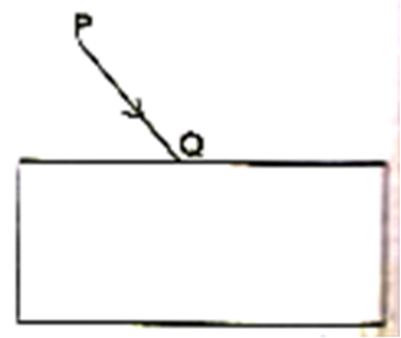

* 1. Copy the diagram and complete the path of the ray of light through the glass block. In your diagram, mark the angle of incidence by letter ‘i’ and the angle of emergence by the letter ‘e’
  2. How are the angle ‘i’ and ‘e’ are related to each other? **[2 marks]**

1. A ray of monochromatic light enters a liquid from air as shown in the diagram given below:

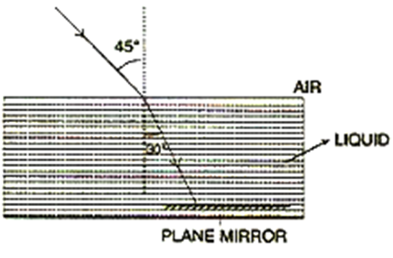

* 1. Copy the diagram and show in the diagram the path of the ray of light after it strikes the mirror and re-enters the medium of air
  2. Mark in your diagram the two angles on the surface of separation when the ray of light moves out from the liquid to air. **[2 marks]**

1. (I) When does a ray of light falling on a lens pass through it undeviated ?

(ii) Which lens can produce a real and inverted image of an object? **[2 marks]**

1. (I) How is the refractive index of a medium related to its real depth and apparent depth?

(ii) Which characteristic property of light is responsible for the blue color of the sky? **[2 marks]**

1. (I) State the laws refraction of light.

(ii) Write a relation between the angle of incidence (i), angle of emergence (e), angle of prism (A) and angle of deviation (d) for a ray of light passing through an equilateral prism **[3 marks]**

1. (I) Suggest one way, in each case, by which we can detect the presence of:
   1. Infrared radiations
   2. Ultraviolet radiation

(ii) Give one use of infrared radiations **[3 marks]**

1. An object is placed in front of a lens between its optical center and the focus and forms a virtual, erect and diminished image
   1. Name the lens which formed this image
   2. Draw a ray diagram to show the formation of the image with the above stated characteristics **[4 marks]**

**2010**

1. (I) what is meant by refraction of light?

(II) What is the cause of refraction of light? **[2 marks]**

1. ‘ The refractive index of diamond is 2.42’ what is meant by this statement? [2 marks]
2. We can burn a piece of paper by focussing the sun rays by using a particular type of lens
   1. Name the type of lens used for the above purpose
   2. Draw a ray diagram to support your answer [2 marks]
3. A ray of light enters a glass slab PQRS, as shown in the diagram. The critical angle of the glass is 42°. Copy this diagram and complete the path of the ray till it emerges from the glass slab. Mark the angles in the diagram wherever necessary.
4. A stick partly immersed in water appears to be bent. Draw a ray diagram to show the bending of the stick when placed in water and viewed obliquely from above. **[3 marks]**
5. A ray of monochromatic light is incident from air on a glass slab :
   1. Draw a labelled ray diagram showing the change in the path of the ray till it emerges from the glass slab.
   2. Name the two rays that are parallel to each other.
   3. Mark the lateral displacement in your diagram. **[3 marks]**
6. An erect, magnified and virtual image is formed, when an object is placed between the optical centre and principal focus of a lens.
   1. Name the lens.
   2. Draw a ray diagram to show the formation of the image with the above stated characteristics. **[4 marks]**
7. Two parallel ray of Red and Violet travelling through air, meet the air glass boundary as shown in the given figure.

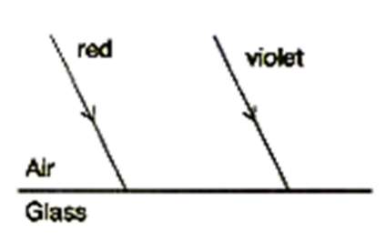

* 1. Will their paths inside the glass be parallel? Air Give a reason for your answer.
  2. Compare the speeds of the two rays inside the glass. **[3 marks]**

**2009**

1. A ray of light strikes the surface of a rectangular glass block such that the angle of incidence is (i) 0° (ii) 42°. Sketch a diagram to show the approximate path taken by the ray in each case as it passes through the glass block and emerges from it. **[2 marks]**
2. State the conditions required for total internal reflection of light to take place. **[2 Marks]**
3. Copy and complete the following table : **[2 marks]**

|  |  |  |  |
| --- | --- | --- | --- |
| Type of lens | Position of Object | Nature of Image | Size of Image |
| Convex | At F |  |  |
| Concave | At infinity |  |  |

1. (i) Why is white light considered to be polychromatic in nature ?

(ii) Give the range of the wavelength of those electromagnetic waves which are visible to us. **[2 marks]**

1. How does the value of angle of deviation produced by a prism change with an increase in the:
   1. value of angle of incidence.
   2. wave-length of incident light ? **[3 marks]**
2. (i) Copy and complete the diagram to show the formation of the image of the object AB.

(ii) what is the name give to X **[3 marks]**



1. (i) The diagram given alongside shows a ray of white light PQ coming from an object P and incident on the surface of a thick glass plane mirror. Copy the diagram and complete it to show the formation of three images of the object P as formed by the mirror.

(ii) Which image will be the brightest image? **[4 marks]**



**2008**

1. (a) A monochromatic beam of light of wavelength X passes from air into a glass block. Write an expression to show the relation between the speed of light in air and the speed of light in glass.

(ii) As the ray of light passes from air to glass, state how the wavelength of light changes. Does it increase, decrease or remain constant? [2 marks]

1. Draw a ray diagram to illustrate the determination of the focal length of a convex lens using an auxiliary plane mirror. [2 marks]
2. What is meant by primary colours ? Name the primary colours of light. [2 marks]
3. Two isosceles right-angled glass prisms are placed near each other as shown in the figure. Complete the path of the light ray entering the first isosceles right-angled glass prism till it emerges from the second identical prism. [2 marks]



1. What is meant by the ‘aperture’ and ‘shutter speed’ of a camera ? How are they related ? [3 marks]
2. (i) Draw a labelled ray diagram to illustrate (1) critical angle (2) total internal reflection, for a ray of light moving from one medium to another.

(ii) Write a formula to express the relationship between refractive index of the denser medium with respect to rarer medium and its critical angle for that pair of media.

(iii) Write a formula to express the relationship between refractive index of the denser medium with respect to rarer medium and its critical angle for that pair of

media. [3 marks]

1. (i) The diagram given alongside shows a ray of light incident on an equilateral glass prism placed in minimum deviation position. Copy the diagram and complete it to show the path of the refracted ray and the emergent ray.

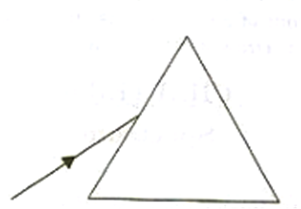

(ii) How are angle of incidence and angle of emergence related to each other in

this position of the prism ? [4 marks]

1. A linear object is placed on the axis of a lens. An image is formed by refraction in the lens. For all positions of the object on the axis of the lens, the positions of the image are always between the lens and the object.
   1. Name the lens.
   2. Draw a ray diagram to show the formation of the image of an object placed in front of the lens at any position of your choice except infinity. [3 marks]

**2007**

1. Why are infrared radiations preferred over ordinary visible light for taking photographs in fog? **[2 marks]**
2. State Snell’s Law of Refraction of light. **[2 marks]**
3. (i) What will be the colour of a blue flower when it is seen in magenta coloured light?

(ii) Name another secondary colour of light in which the flower will show the same colour as it shows in the magenta coloured light. **[2 marks]**

1. An object is placed in front of a converging lens at a distance greater than twice the focal length of the lens. Draw a ray diagram to show the formation of the image. **[2 marks]**
2. Mention one difference between reflection of light from a plane mirror and total internal reflection of light from a prism. **[2 marks]**
3. The diagram given alongside shows a right-angled prism with a ray of light incident on the side AB. (The critical angle for glass is 42°).



* 1. Copy the diagram and complete the path of the ray of light in and out of the glass prism.
  2. What is the value of the angle of deviation shown by the ray? **[3 marks]**

1. (i) A particular type of high energy invisible electromagnetic rays help us to study the structure of crystals. Name these rays and give another important use of these rays.

(ii) How does the speed of light in glass change on increasing the wavelength of light? **[3 marks]**

1. (i) With the help of a well-labelled diagram show that the apparent depth of an object, such as a coin, in water is less than its real depth.

(ii) How is the refractive index of water related to the real depth and the apparent depth of a column of water? **[4 marks]**

2006

1. PQ and PR are two light rays emerging from the object P as shown in the figure

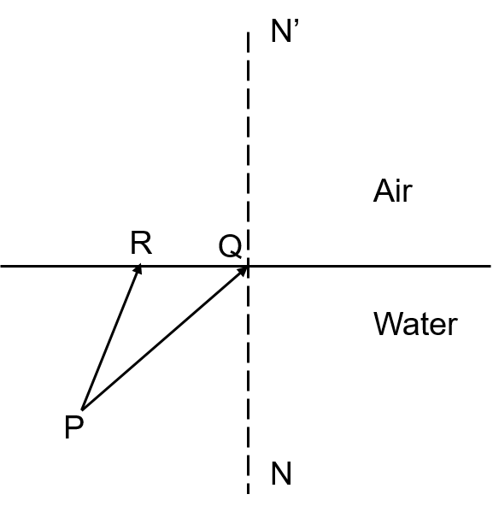

* 1. What is the special name given to the angle of incidence ( ∠PQN) of ray PQ
  2. Copy the ray diagram and complete it to show the position of the image of the object ‘P’, when seen obliquely from above
  3. Name the phenomenon that occurs, if the angle of incidence ∠PQN is increased still further [4 marks]

2004

1. (i) define critical angle

(ii) a ray of light passes through a right angled prism as shown in the figure. State the angles of incidence at the faces of AC and BC

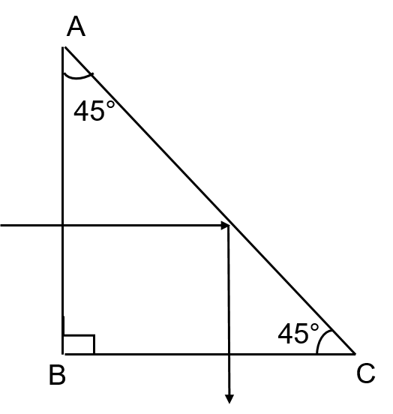

2002

1. (i) Two isosceles right-angled prisms are arranged as shown in the figure. Copy the diagram and complete the path of the ray AB along which it passes through the prisms and comes out

(ii) Name the phenomenon being displayed by the path of the ray in the diagram

